RESULTS FROM FIELD DATA 2015 – 21/03/2016

Butterfly seed predation: effects on plant reproductive output and context-dependence

Objectives / questions

1) What are the effects of plant traits (phenology, flower production, shoot height), environmental context (soil temperature, height of surrounding vegetation) and community context (ant abundance at the plant level, distance to nearest plant with ants) on intensity of predispersal seed predation?

H1: Predispersal seed predation is stronger on plants with an early phenology, high number of flowers and higher shoots, when the surrounding vegetation is short and when ants are present in the proximity of the plant. Reasons for an effect of soil temperature?

2) What are the (direct / indirect) effects of plant traits and context on fitness / reproductive output (fruit / seed production) / (fruit / seed set)?

H2: Higher soil temperatures (speeding up fruit maturation?) and higher flower production directly increase fitness. The effects of phenology, height and ants are indirect effects through seed predation (plants flowering early, being higher than the surrounding vegetation and having high ant abundance have higher seed predation and therefore lower fitness).

3) What is the relative importance of plant traits vs. context for explaining the variation in predispersal seed predation intensity? What is the relative importance of plant traits, context and seed predation for explaining the variation in plant fitness / reproductive output? (variation partitioning)

H3: … We could hypothesize that the context is (nearly) as important as plant traits for explaining variation in seed predation, and that the interaction is (nearly) as important as plant traits for explaining variation in fitness / reproductive output.

…

1) Effects of plant traits, environmental and community context on seed predation

I constructed a GLM including the interactions of all variables * population, then performed model selection and averaging using all models with AIC < 2. Explanatory variables were standardized before including them in the model. R2 is calculated from the best model (lowest AIC). Tried including the phenology x ants interaction but it was not significant in any of the models, so I removed it. Temperature: used 4 different variables: average daily minimum (avg_d_min_ja), maximum (avg_d_max_ja), standard deviation (avg_d_sd_ja) and range (avg_d_range_ja) for july-august.

Model for n_eggs_max n=301

> summary(model.avg(modelseg_a1_nb, subset = delta < 2))

Call:

model.avg.model.selection(object = modelseg_a1_nb, subset = delta <

2)

Component model call:

glm.nb(formula = n_eggs_max ~ <9 unique rhs>, data = data1comp, na.action = na.fail, init.theta = 0.8400529073, link = log)

Model-averaged coefficients:

(full average)

Estimate Std. Error Adjusted SE z value Pr(>|z|)

(Intercept) 2.04150 0.21298 0.21376 9.551 < 2e-16 ***

populationRemmene -0.77369 0.36044 0.36178 2.139 0.032474 *

populationTånga Hed -1.23148 0.35713 0.35854 3.435 0.000593 ***

z.avg_d_min_ja -0.84622 0.20884 0.20934 4.042 5.29e-05 ***

z.most_adv 0.52444 0.12050 0.12100 4.334 1.46e-05 ***

z.n_fl_corrected 0.50888 0.32811 0.32902 1.547 0.121943

z.n_redants 0.53216 0.18682 0.18745 2.839 0.004526 **

z.shoot_h 0.46231 0.21605 0.21660 2.134 0.032810 *

z.veg_h_mean -1.00147 0.26126 0.26203 3.822 0.000132 ***

populationRemmene:z.avg_d_min_ja 0.42089 0.37103 0.37153 1.133 0.257280

populationTånga Hed:z.avg_d_min_ja 0.33091 0.34811 0.34888 0.949 0.342868

populationRemmene:z.n_fl_corrected 0.03976 0.36530 0.36632 0.109 0.913567

populationTånga Hed:z.n_fl_corrected -0.20360 0.35267 0.35350 0.576 0.564640

populationRemmene:z.n_redants -0.08738 0.38978 0.39141 0.223 0.823356

populationTånga Hed:z.n_redants -0.42747 0.22298 0.22366 1.911 0.055971 .

populationRemmene:z.shoot_h -0.32299 0.35407 0.35452 0.911 0.362259

populationTånga Hed:z.shoot_h -0.10392 0.23056 0.23126 0.449 0.653177

populationRemmene:z.veg_h_mean 0.54579 0.35770 0.35861 1.522 0.128022

populationTånga Hed:z.veg_h_mean 0.87815 0.32500 0.32610 2.693 0.007084 **

Relative variable importance:

population z.avg_d_min_ja z.most_adv z.n_fl_corrected z.n_redants z.shoot_h z.veg_h_mean population:z.veg_h_mean

Importance: 1.00 1.00 1.00 1.00 1.00 1.00 1.00 1.00

N containing models: 9 9 9 9 9 9 9 9

population:z.n_redants population:z.avg_d_min_ja population:z.shoot_h population:z.n_fl_corrected

Importance: 0.93 0.65 0.55 0.47

N containing models: 8 5 4 4



> r.squaredLR(modeleg_a1_nb_best)

[1] 0.3695822

attr(,"adj.r.squared")

[1] 0.3722438

Results using other temperature variables

Estimate Std. Error Adjusted SE z value Pr(>|z|)

(Intercept) 1.4641 0.2395 0.2403 6.093 < 2e-16 ***

populationRemmene 0.5036 0.3283 0.3295 1.528 0.126472

populationTånga Hed -0.6333 0.3710 0.3726 1.700 0.089177 .

z.avg_d_max_ja -0.8829 0.1926 0.1934 4.564 5.00e-06 ***

z.most_adv 0.4923 0.1207 0.1212 4.062 4.86e-05 ***

z.n_fl_corrected 0.7382 0.4121 0.4128 1.788 0.073718 .

z.n_redants 0.6451 0.1783 0.1791 3.602 0.000316 ***

z.shoot_h 0.3288 0.1224 0.1228 2.677 0.007439 **

z.veg_h_mean -1.2337 0.2284 0.2293 5.379 1.00e-07 ***

populationRemmene:z.avg_d_max_ja 1.3786 0.2741 0.2753 5.008 6.00e-07 ***

populationTånga Hed:z.avg_d_max_ja 0.6729 0.2803 0.2815 2.390 0.016829 *

populationRemmene:z.n_fl_corrected -0.2780 0.3677 0.3687 0.754 0.450842

populationTånga Hed:z.n_fl_corrected -0.4472 0.4442 0.4448 1.005 0.314679

populationRemmene:z.n_redants -0.1175 0.4146 0.4163 0.282 0.777853

populationTånga Hed:z.n_redants -0.5598 0.2030 0.2038 2.747 0.006021 **

populationRemmene:z.veg_h_mean 0.8747 0.2741 0.2753 3.177 0.001486 **

populationTånga Hed:z.veg_h_mean 1.1056 0.3023 0.3035 3.642 0.000270 ***

Estimate Std. Error z value Pr(>|z|)

(Intercept) 1.72948 0.25435 6.800 1.05e-11 ***

populationRemmene -0.04609 0.32778 -0.141 0.888181

populationTånga Hed -0.94681 0.39437 -2.401 0.016358 *

z.avg_d_sd_ja -0.41931 0.20770 -2.019 0.043507 *

z.most_adv 0.46221 0.12533 3.688 0.000226 ***

z.n_fl_corrected 1.19075 0.32655 3.646 0.000266 ***

z.n_redants 0.61207 0.17517 3.494 0.000475 ***

z.shoot_h 0.32340 0.11567 2.796 0.005175 **

z.veg_h_mean -0.95458 0.21534 -4.433 9.30e-06 ***

populationRemmene:z.avg_d_sd_ja 0.88886 0.25450 3.493 0.000478 ***

populationTånga Hed:z.avg_d_sd_ja 0.40167 0.28256 1.422 0.155160

populationRemmene:z.n_fl_corrected -0.61296 0.37994 -1.613 0.106676

populationTånga Hed:z.n_fl_corrected -0.93199 0.33224 -2.805 0.005028 **

populationRemmene:z.veg_h_mean 0.55103 0.26959 2.044 0.040958 *

populationTånga Hed:z.veg_h_mean 0.92556 0.29410 3.147 0.001649 **

populationRemmene:z.n_redants -0.07000 0.42277 -0.166 0.868492

populationTånga Hed:z.n_redants -0.52671 0.20177 -2.610 0.009042 **

Estimate Std. Error z value Pr(>|z|)

(Intercept) 1.78485 0.24694 7.228 4.91e-13 ***

populationRemmene -0.08052 0.32224 -0.250 0.802677

populationTånga Hed -0.96970 0.38751 -2.502 0.012337 *

z.avg_d_range_ja -0.38133 0.19822 -1.924 0.054382 .

z.most_adv 0.47065 0.12531 3.756 0.000173 ***

z.n_fl_corrected 1.23062 0.32678 3.766 0.000166 ***

z.n_redants 0.60228 0.17543 3.433 0.000597 ***

z.shoot_h 0.30592 0.11550 2.649 0.008078 **

z.veg_h_mean -0.92180 0.21342 -4.319 1.57e-05 ***

populationRemmene:z.avg_d_range_ja 0.81970 0.24990 3.280 0.001038 **

populationTånga Hed:z.avg_d_range_ja 0.29077 0.26910 1.080 0.279920

populationRemmene:z.n_fl_corrected -0.64899 0.38018 -1.707 0.087808 .

populationTånga Hed:z.n_fl_corrected -0.97095 0.33221 -2.923 0.003471 **

populationRemmene:z.veg_h_mean 0.51133 0.26761 1.911 0.056038 .

populationTånga Hed:z.veg_h_mean 0.87195 0.29347 2.971 0.002967 **

populationRemmene:z.n_redants -0.08623 0.42350 -0.204 0.838655

populationTånga Hed:z.n_redants -0.51805 0.20201 -2.565 0.010332 *

2) Effects of plant traits, environmental and community context on fitness / reproductive output

Same procedure: first constructed a model including the interactions of all variables * population (results not shown), then performed model selection and model averaging using all models with AIC < 2.

Response variables: number of intact fruits, number of developed seeds per plant.

n plants where information on seeds is available (many with n fruits = 0)

population n plants n plants with >0 seeds prop plants >0 seeds

Högsjön 96 26 0,27083333

Remmene 84 8 0,0952381

Tånga Hed 71 60 0,84507042

After removal of some plants with missing data for temperature and two outliers, n=244 plants (93 Högsjön, 82 Remmene, 69 Tanga).

The effect of the interaction with the seed predator was included in the models as the number of eggs per plant.

2.1) Response = n_intact_fruits

> model1fr_a1<-glm(n_intact_fruits~(z.shoot_h+z.most_adv+z.n_fl_corrected+z.avg_d_min_ja+

z.n_eggs_max)*population ,family="poisson",na.action = "na.fail")

> summary(model.avg(models1fr_a1, subset = delta < 2))

Call:

model.avg.model.selection(object = models1fr_a1, subset = delta <

2)

Component model call:

glm(formula = n_intact_fruits ~ <4 unique rhs>, family = poisson, na.action = na.fail)

Model-averaged coefficients:

(full average)

Estimate Std. Error Adjusted SE z value Pr(>|z|)

(Intercept) -1.13017 0.21891 0.21975 5.143 3e-07 ***

populationRemmene -0.22923 0.36930 0.37073 0.618 0.5364

populationTånga Hed 1.63968 0.24364 0.24453 6.705 <2e-16 ***

z.avg_d_min_ja 0.22734 0.10985 0.11029 2.061 0.0393 *

z.most_adv 0.12481 0.09436 0.09459 1.320 0.1870

z.n_eggs_max -0.40369 0.06042 0.06066 6.655 <2e-16 ***

z.n_fl_corrected 0.29779 0.20815 0.20870 1.427 0.1536

z.shoot_h 0.16633 0.12433 0.12469 1.334 0.1822

populationRemmene:z.shoot_h 0.09555 0.22530 0.22560 0.424 0.6719

populationTånga Hed:z.shoot_h 0.03669 0.11106 0.11133 0.330 0.7417

populationRemmene:z.n_fl_corrected 0.12193 0.33861 0.33911 0.360 0.7192

populationTånga Hed:z.n_fl_corrected 0.05410 0.19757 0.19809 0.273 0.7847

Relative variable importance:

population z.avg_d_min_ja z.n_eggs_max z.n_fl_corrected z.shoot_h z.most_adv

Importance: 1.00 1.00 1.00 1.00 1.00 0.81

N containing models: 4 4 4 4 4 3

population:z.shoot_h population:z.n_fl_corrected

Importance: 0.21 0.17

N containing models: 1 1

When removing predation from the model, the effect of phenology is not even included in the set of best models (so no selection for late flowering when not considering the effect of predation)

Estimate Std. Error Adjusted SE z value Pr(>|z|)

(Intercept) -1.15387 0.21122 0.21199 5.443 1e-07 ***

populationRemmene -0.17953 0.37426 0.37578 0.478 0.6328

populationTånga Hed 1.78983 0.22585 0.22665 7.897 <2e-16 ***

z.avg_d_min_ja 0.33347 0.15633 0.15676 2.127 0.0334 *

z.n_fl_corrected 0.30983 0.05279 0.05298 5.848 <2e-16 ***

z.shoot_h 0.01553 0.08767 0.08797 0.177 0.8598

populationRemmene:z.shoot_h 0.08609 0.21781 0.21806 0.395 0.6930

populationTånga Hed:z.shoot_h 0.01428 0.08127 0.08155 0.175 0.8610

populationRemmene:z.avg_d_min_ja -0.06639 0.22465 0.22514 0.295 0.7681

populationTånga Hed:z.avg_d_min_ja -0.05389 0.15700 0.15723 0.343 0.7318

Using other variables, the effect of temperature is not significant

Estimate Std. Error Adjusted SE z value Pr(>|z|)

(Intercept) -0.91463 0.21107 0.21182 4.318 1.57e-05 ***

populationRemmene -0.62188 0.35944 0.36063 1.724 0.0846 .

populationTånga Hed 1.36990 0.26724 0.26820 5.108 3.00e-07 ***

z.avg_d_max_ja 0.16840 0.14440 0.14470 1.164 0.2445

z.most_adv 0.14086 0.09249 0.09275 1.519 0.1288

z.n_eggs_max -0.45327 0.20513 0.20550 2.206 0.0274 *

z.n_fl_corrected 0.35242 0.17361 0.17405 2.025 0.0429 *

z.shoot_h 0.16066 0.10158 0.10191 1.576 0.1149

populationRemmene:z.avg_d_max_ja -0.09843 0.27390 0.27422 0.359 0.7196

populationTånga Hed:z.avg_d_max_ja -0.03537 0.11643 0.11667 0.303 0.7618

populationRemmene:z.shoot_h 0.05551 0.17735 0.17757 0.313 0.7546

populationTånga Hed:z.shoot_h 0.01611 0.07863 0.07886 0.204 0.8381

populationRemmene:z.n_eggs_max 0.06028 0.23204 0.23243 0.259 0.7954

populationTånga Hed:z.n_eggs_max 0.05273 0.19948 0.19980 0.264 0.7918

populationRemmene:z.n_fl_corrected 0.07185 0.26709 0.26747 0.269 0.7882

populationTånga Hed:z.n_fl_corrected 0.03486 0.16155 0.16194 0.215 0.8296

(full average)

Estimate Std. Error Adjusted SE z value Pr(>|z|)

(Intercept) -0.97663 0.22807 0.22884 4.268 1.98e-05 ***

populationRemmene -0.59108 0.33764 0.33885 1.744 0.0811 .

populationTånga Hed 1.53676 0.26705 0.26797 5.735 < 2e-16 ***

z.most_adv 0.18219 0.07950 0.07982 2.282 0.0225 *

z.n_eggs_max -0.49782 0.24560 0.24603 2.023 0.0430 *

z.n_fl_corrected 0.30797 0.21549 0.21603 1.426 0.1540

z.shoot_h 0.13368 0.11718 0.11753 1.137 0.2553

populationRemmene:z.shoot_h 0.07863 0.20875 0.20902 0.376 0.7068

populationTånga Hed:z.shoot_h 0.02815 0.10056 0.10082 0.279 0.7801

z.avg_d_sd_ja 0.00853 0.03568 0.03578 0.238 0.8116

populationRemmene:z.n_fl_corrected 0.12082 0.34603 0.34650 0.349 0.7273

populationTånga Hed:z.n_fl_corrected 0.05787 0.20754 0.20804 0.278 0.7809

populationRemmene:z.n_eggs_max 0.09684 0.29093 0.29140 0.332 0.7396

populationTånga Hed:z.n_eggs_max 0.08047 0.24294 0.24334 0.331 0.7409

(full average)

Estimate Std. Error Adjusted SE z value Pr(>|z|)

(Intercept) -0.97374 0.22787 0.22863 4.259 2.05e-05 ***

populationRemmene -0.59331 0.33698 0.33819 1.754 0.0794 .

populationTånga Hed 1.53177 0.26803 0.26895 5.695 < 2e-16 ***

z.most_adv 0.18199 0.07950 0.07983 2.280 0.0226 *

z.n_eggs_max -0.49569 0.24369 0.24412 2.031 0.0423 *

z.n_fl_corrected 0.30970 0.21382 0.21435 1.445 0.1485

z.shoot_h 0.13400 0.11642 0.11676 1.148 0.2511

z.avg_d_range_ja 0.01089 0.03795 0.03805 0.286 0.7747

populationRemmene:z.shoot_h 0.07704 0.20693 0.20719 0.372 0.7100

populationTånga Hed:z.shoot_h 0.02758 0.09962 0.09988 0.276 0.7824

populationRemmene:z.n_fl_corrected 0.11839 0.34295 0.34341 0.345 0.7303

populationTånga Hed:z.n_fl_corrected 0.05670 0.20560 0.20609 0.275 0.7832

populationRemmene:z.n_eggs_max 0.09489 0.28831 0.28877 0.329 0.7425

populationTånga Hed:z.n_eggs_max 0.07885 0.24075 0.24114 0.327 0.7437

2.2) Response = seed_n_per_shoot

> model2se_c1<-zeroinfl(round(seed_n_per_shoot)~(z.shoot_h+z.most_adv+z.n_fl_corrected+

+ z.avg_d_min_ja+z.n_eggs_max)*population,dist="negbin",na.action="na.fail",data=data2compA)

> summary(model.avg(get.models(models2se_c1,subset=delta<2,cluster=clust)))

Call:

model.avg.default(object = get.models(models2se_c1, subset = delta <

2, cluster = clust))

Component model call:

zeroinfl(formula = <13 unique values>, data = data2compA, na.action = na.fail, dist =

negbin)

Model-averaged coefficients:

(full average)

Estimate Std. Error z value Pr(>|z|)

count_(Intercept) 5.70507 0.30526 18.689 < 2e-16 ***

count_populationRemmene 0.33328 0.40905 0.815 0.415206

count_populationTånga Hed 1.36662 0.34003 4.019 5.84e-05 ***

count_z.avg_d_min_ja -0.03379 0.10676 0.317 0.751603

count_z.most_adv 0.56884 0.49693 1.145 0.252334

count_z.n_eggs_max -0.32881 0.08843 3.718 0.000200 ***

count_z.n_fl_corrected 0.23521 0.34438 0.683 0.494603

count_populationRemmene:z.most_adv -0.69185 0.71937 0.962 0.336178

count_populationTånga Hed:z.most_adv -0.44769 0.49808 0.899 0.368737

zero_(Intercept) 0.98430 0.56033 1.757 0.078976 .

zero_populationRemmene 0.91582 0.86267 1.062 0.288410

zero_populationTånga Hed -1.07497 0.70367 1.528 0.126600

zero_z.avg_d_min_ja -0.36760 0.36950 0.995 0.319796

zero_z.most_adv -0.57689 0.55409 1.041 0.297814

zero_z.n_eggs_max 1.35102 0.36058 3.747 0.000179 ***

zero_z.n_fl_corrected -0.72819 0.72328 1.007 0.314039

zero_populationRemmene:z.most_adv -0.17425 0.59271 0.294 0.768773

zero_populationTånga Hed:z.most_adv -0.39946 0.71175 0.561 0.574632

count_z.shoot_h 0.06526 0.09956 0.655 0.512155

zero_z.shoot_h -0.21535 0.28000 0.769 0.441824

count_populationRemmene:z.n_fl_corrected 0.23725 0.48280 0.491 0.623141

count_populationTånga Hed:z.n_fl_corrected 0.21905 0.33502 0.654 0.513217

zero_populationRemmene:z.n_fl_corrected -0.37865 0.72687 0.521 0.602417

zero_populationTånga Hed:z.n_fl_corrected -0.82108 1.09926 0.747 0.455100

Relative variable importance:

count_population count_z.most_adv count_z.n_eggs_max count_z.n_fl_corrected

Importance: 1.00 1.00 1.00 1.00

N containing models: 13 13 13 13

zero_population zero_z.most_adv zero_z.n_eggs_max zero_z.n_fl_corrected

Importance: 1.00 1.00 1.00 1.00

N containing models: 13 13 13 13

count_z.avg_d_min_ja zero_z.avg_d_min_ja count_population:z.most_adv

Importance: 0.60 0.60 0.54

N containing models: 7 7 7

zero_population:z.most_adv count_z.shoot_h zero_z.shoot_h

Importance: 0.54 0.50 0.50

N containing models: 7 7 7

count_population:z.n_fl_corrected zero_population:z.n_fl_corrected

Importance: 0.43 0.43

N containing models: 6 6

Temperature is not significant and the same happens when including the other temperature variables (not shown)

The piecewiseSEM does not support zero-inflated models by now. I got the suggestion from Jon Lefcheck, the author of the package, to use a quasipoisson distribution (which can be used with glm) instead of the zero-inflated one and it seems that the fitted values are quite similar (see graph below).

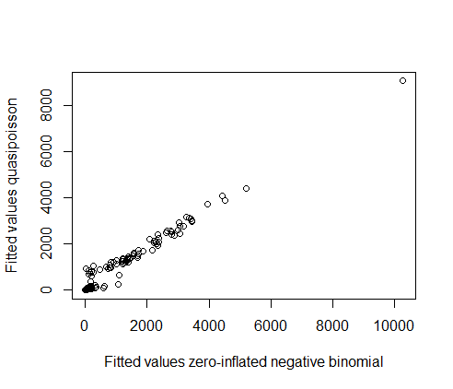

And the results of the model averaging for the glm with quasipoisson distribution (if we show both the results of these models and the path analyses, it would make sense to use the same distribution):

> summary(model.avg(models2se_c1_q,subset=delta<2)) #Result model averaging with quasipoisson

Call:

model.avg(object = models2se_c1_q, subset = delta < 2)

Component model call:

glm(formula = round(seed_n_per_shoot) ~ <3 unique rhs>, family = x.quasipoisson, na.action =

na.fail)

Component models:

df logLik QAIC delta weight

1/2/3/4/5/6/8/9/10 14 -39712.20 262.32 0.00 0.45

1/3/4/5/6/8/9/10 13 -40126.58 262.75 0.42 0.36

1/2/3/4/5/6/7/8/9/10 16 -39329.63 264.09 1.76 0.19

Term codes:

population z.avg_d_min_ja z.most_adv z.n_eggs_max

1 2 3 4

z.n_fl_corrected z.shoot_h population:z.avg_d_min_ja population:z.most_adv

5 6 7 8

population:z.n_eggs_max population:z.shoot_h

9 10

Model-averaged coefficients:

(full average)

Estimate Std. Error Adjusted SE z value Pr(>|z|)

(Intercept) 4.46619 0.46096 0.46330 9.640 <2e-16 ***

populationRemmene -2.41434 1.26749 1.27338 1.896 0.0580 .

populationTånga Hed 2.38390 0.46856 0.47098 5.062 4e-07 ***

z.avg_d_min_ja 0.12446 0.18868 0.18939 0.657 0.5111

z.most_adv 1.34464 0.79512 0.79929 1.682 0.0925 .

z.n_eggs_max -1.13952 0.52652 0.52928 2.153 0.0313 *

z.n_fl_corrected 0.38064 0.05815 0.05843 6.514 <2e-16 ***

z.shoot_h 0.16424 0.25737 0.25872 0.635 0.5255

populationRemmene:z.most_adv -0.47014 0.86008 0.86451 0.544 0.5866

populationTånga Hed:z.most_adv -1.17625 0.79784 0.80203 1.467 0.1425

populationRemmene:z.n_eggs_max -2.25749 1.62240 1.63064 1.384 0.1662

populationTånga Hed:z.n_eggs_max 0.81323 0.52814 0.53092 1.532 0.1256

populationRemmene:z.shoot_h 0.92126 0.36399 0.36590 2.518 0.0118 *

populationTånga Hed:z.shoot_h 0.01404 0.26502 0.26641 0.053 0.9580

populationRemmene:z.avg_d_min_ja -0.15845 0.41639 0.41721 0.380 0.7041

populationTånga Hed:z.avg_d_min_ja -0.01645 0.15422 0.15499 0.106 0.9155

Relative variable importance:

population z.most_adv z.n_eggs_max z.n_fl_corrected z.shoot_h population:z.most_adv

Importance: 1.00 1.00 1.00 1.00 1.00 1.00

N containing models: 3 3 3 3 3 3

population:z.n_eggs_max population:z.shoot_h z.avg_d_min_ja

Importance: 1.00 1.00 0.64

N containing models: 3 3 2

population:z.avg_d_min_ja

Importance: 0.19

N containing models: 1

PATH ANALYSES

Number of intact fruits (n=303)

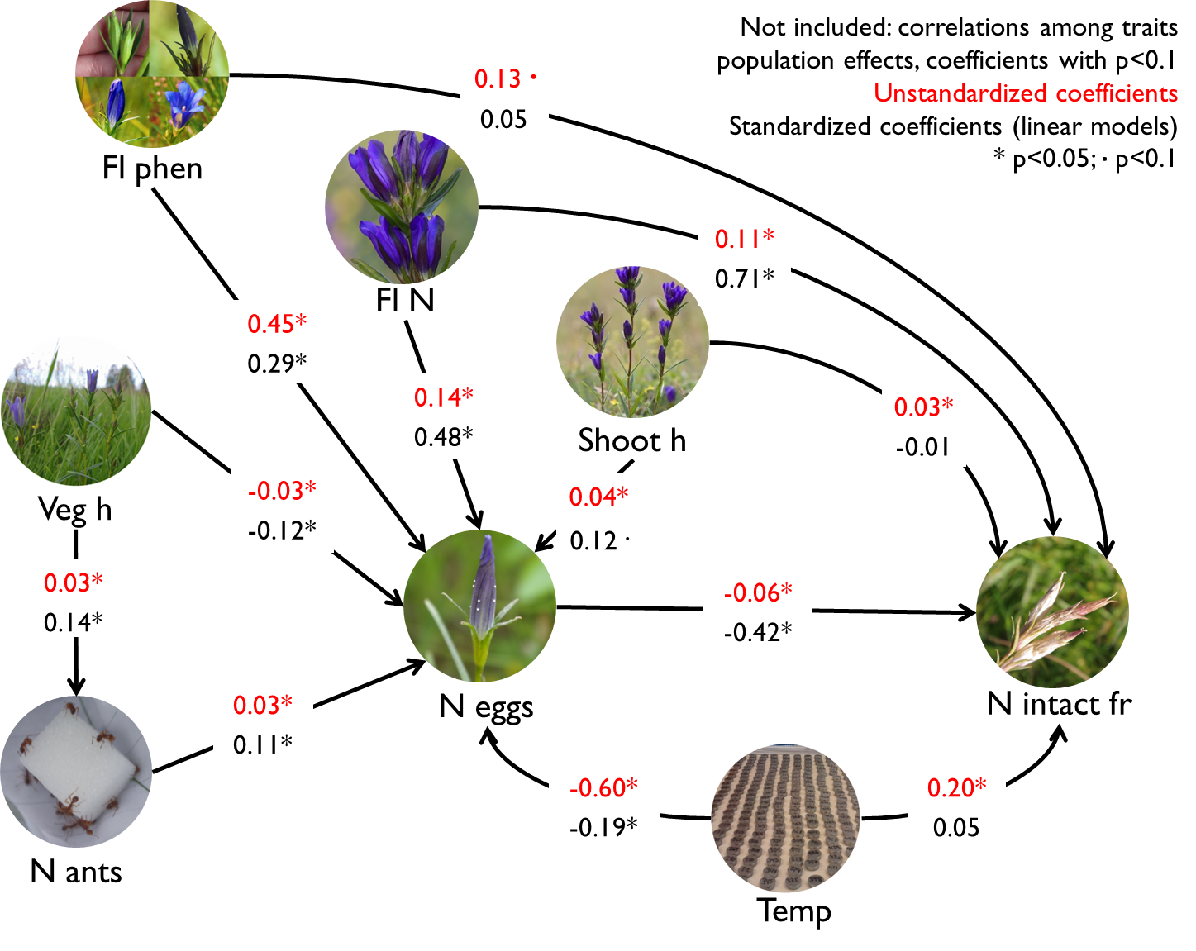

> fruits.modList<-list(

glm(n_intact_fruits~most_adv+shoot_h+n_fl_corrected+avg_d_min_ja+n_eggs_max+population,family=poisson",na.action="na.fail",data=data1comp),

glm.nb(n_eggs_max~most_adv+n_fl_corrected+shoot_h+avg_d_min_ja+veg_h_mean+n_redants+population,na.action="na.fail",data=data1comp),

glm.nb(n_redants~veg_h_mean+population,na.action="na.fail",data=data1comp))

> sem.fit(fruits.modList, data1comp, corr.errors = c("most_adv~~n_fl_corrected","shoot_h~~n_fl_corrected","most_adv~~shoot_h"))

$missing.paths

missing.path estimate std.error df crit.value p.value

1 n_redants ~ most_adv + ... -0.1897 0.1045 298 -1.8154 0.0695

2 n_redants ~ shoot_h + ... 0.0129 0.0154 298 0.8349 0.4038

3 n_redants ~ n_fl_corrected + ... -0.0145 0.0371 298 -0.3907 0.6960

4 n_redants ~ avg_d_min_ja + ... -0.1197 0.1234 298 -0.9700 0.3320

5 n_intact_fruits ~ veg_h_mean + ... -0.0071 0.0063 294 -1.1321 0.2576

6 n_intact_fruits ~ n_redants + ... -0.0052 0.0054 293 -0.9685 0.3328

$Fisher.C

fisher.c df p.value

1 14.99 12 0.242

$AIC

AIC AICc K n

1 60.99 64.947 23 303

> sem.model.fits(fruits.modList)

Class Family Link N Marginal Conditional

1 glm poisson log 303 0.7084168 NA

2 negbin Negative Binomial(0.7278) log 303 0.3171593 NA

3 negbin Negative Binomial(0.4535) log 303 0.1639056 NA

> sem.coefs(fruits.modList, data1comp,

+ corr.errors = c("most_adv~~n_fl_corrected","shoot_h~~n_fl_corrected","most_adv~~shoot_h"))

response predictor estimate std.error p.value

7 n_intact_fruits populationTånga Hed 1.57451265 0.218769553 0.0000

5 n_intact_fruits n_eggs_max -0.06110247 0.008924824 0.0000

3 n_intact_fruits n_fl_corrected 0.11076213 0.019363346 0.0000

2 n_intact_fruits shoot_h 0.03061218 0.010847032 0.0048

4 n_intact_fruits avg_d_min_ja 0.20448484 0.101014170 0.0429

1 n_intact_fruits most_adv 0.13251488 0.067706234 0.0503

6 n_intact_fruits populationRemmene -0.26453896 0.346695216 0.4454

11 n_eggs_max avg_d_min_ja -0.60213199 0.108277450 0.0000

8 n_eggs_max most_adv 0.45170825 0.100701611 0.0000

15 n_eggs_max populationTånga Hed -1.19200280 0.311225234 0.0001

12 n_eggs_max veg_h_mean -0.03060568 0.008318170 0.0002

9 n_eggs_max n_fl_corrected 0.14496882 0.041091969 0.0004

14 n_eggs_max populationRemmene -0.81696634 0.275977577 0.0031

13 n_eggs_max n_redants 0.02515679 0.008814514 0.0043

10 n_eggs_max shoot_h 0.03785087 0.016180925 0.0193

18 n_redants populationTånga Hed 1.17427017 0.237738789 0.0000

16 n_redants veg_h_mean 0.02614917 0.007194206 0.0003

17 n_redants populationRemmene -0.79815244 0.229935323 0.0005

19 ~~ most_adv ~~ n_fl_corrected 0.69330622 NA 0.0000

21 ~~ most_adv ~~ shoot_h 0.33762952 NA 0.0000

20 ~~ shoot_h ~~ n_fl_corrected 0.57492950 NA 0.0000

> sem.coefs(fruits.modList_lin, data1comp,standardize="scale",

+ corr.errors = c("most_adv~~n_fl_corrected","shoot_h~~n_fl_corrected","most_adv~~shoot_h"))

response predictor estimate std.error p.value

3 n_intact_fruits n_fl_corrected 0.70924084 0.05808349 0.0000

5 n_intact_fruits n_eggs_max -0.41974773 0.04049657 0.0000

7 n_intact_fruits populationTånga Hed 0.58860845 0.10980232 0.0000

4 n_intact_fruits avg_d_min_ja 0.05178843 0.04811728 0.2827

1 n_intact_fruits most_adv 0.04788235 0.05059875 0.3448

2 n_intact_fruits shoot_h -0.01290794 0.04080581 0.7520

6 n_intact_fruits populationRemmene -0.02802028 0.11106061 0.8010

9 n_eggs_max n_fl_corrected 0.48045095 0.07856350 0.0000

15 n_eggs_max populationTånga Hed -0.81715055 0.17173346 0.0000

8 n_eggs_max most_adv 0.28934944 0.07085971 0.0001

11 n_eggs_max avg_d_min_ja -0.19447270 0.06751432 0.0043

13 n_eggs_max n_redants 0.11226748 0.04959444 0.0243

12 n_eggs_max veg_h_mean -0.11799479 0.05788957 0.0424

10 n_eggs_max shoot_h 0.12103162 0.06469961 0.0624

14 n_eggs_max populationRemmene -0.26029684 0.15858737 0.1018

18 n_redants populationTånga Hed 0.70206581 0.14237605 0.0000

16 n_redants veg_h_mean 0.14434260 0.05929974 0.0155

17 n_redants populationRemmene -0.28337222 0.13229407 0.0330

19 ~~ most_adv ~~ n_fl_corrected 0.69330622 NA 0.0000

21 ~~ most_adv ~~ shoot_h 0.33762952 NA 0.0000

20 ~~ shoot_h ~~ n_fl_corrected 0.57492950 NA 0.0000

Number of developed seeds, using distribution=quasipoisson (n=245)

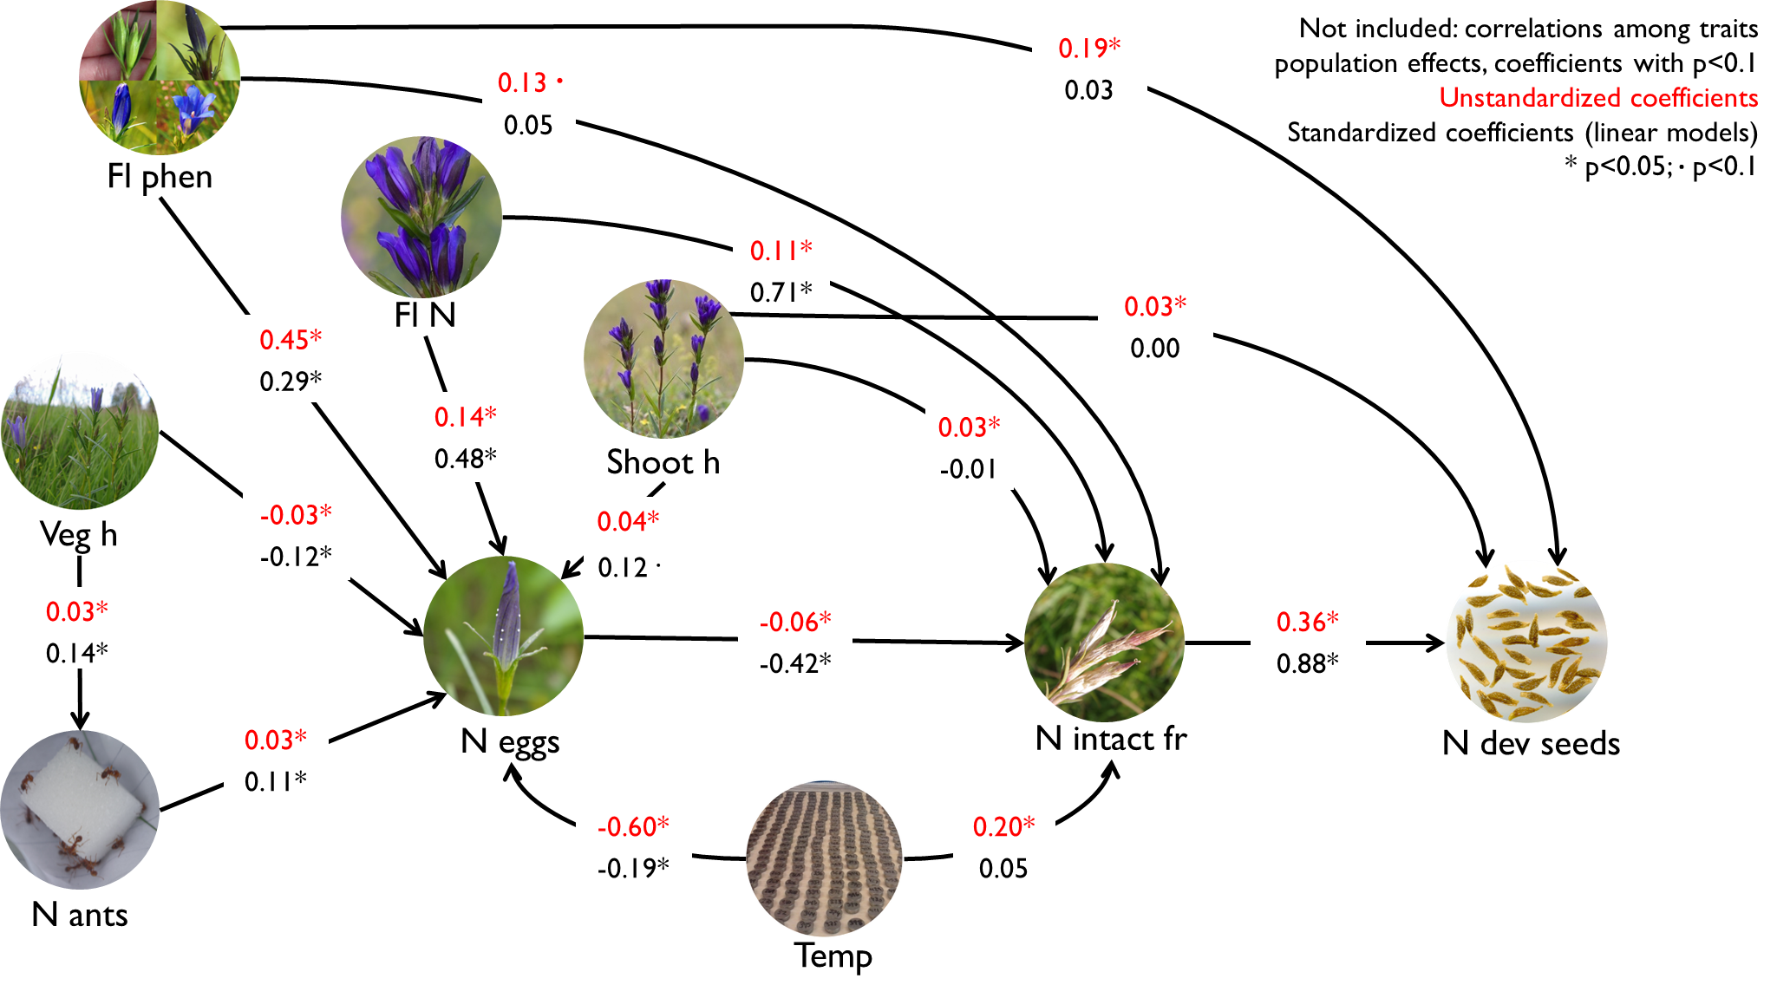

> seeds.modList<-list(

glm(round(seed_n_per_shoot)~most_adv+shoot_h+n_fl_corrected+avg_d_min_ja+n_eggs_max+populationn_intact_fruits,family="quasipoisson",na.action="na.fail",data=data2compA),

glm(n_intact_fruits~most_adv+shoot_h+n_fl_corrected+avg_d_min_ja+n_eggs_max+population,family="poisson",na.action="na.fail",data=data2compA),

glm.nb(n_eggs_max~most_adv+n_fl_corrected+shoot_h+avg_d_min_ja+veg_h_mean+n_redants+population,na.action="na.fail",data=data2compA),

glm.nb(n_redants~veg_h_mean+population,na.action="na.fail",data=data2compA)

)

> sem.fit(seeds.modList, data2compA,

corr.errors = c("most_adv~~n_fl_corrected","shoot_h~~n_fl_corrected","most_adv~~shoot_h"))

$missing.paths

missing.path estimate std.error df crit.value p.value

1 n_redants ~ most_adv + ... -0.1210 0.1220 240 -0.9915 0.3214

2 n_redants ~ shoot_h + ... 0.0213 0.0181 240 1.1757 0.2397

3 n_redants ~ n_fl_corrected + ... 0.0239 0.0467 240 0.5119 0.6087

4 n_redants ~ avg_d_min_ja + ... -0.1202 0.1363 240 -0.8824 0.3776

5 round(seed_n_per_shoot) ~ veg_h_mean + ... -0.0002 0.0059 235 -0.0275 0.9781

6 n_intact_fruits ~ veg_h_mean + ... -0.0123 0.0076 236 -1.6213 0.1050

7 round(seed_n_per_shoot) ~ n_redants + ... 0.0030 0.0052 234 0.5723 0.5676

8 n_intact_fruits ~ n_redants + ... -0.0023 0.0067 235 -0.3460 0.7293

$Fisher.C

fisher.c df p.value

1 14.38 16 0.57

$AIC

AIC AICc K n

1 78.38 88.342 32 245

> sem.model.fits(seeds.modList)

Class Family Link N Marginal Conditional

1 glm quasipoisson log 245 0.8522495 NA

2 glm poisson log 245 0.7283742 NA

3 negbin Negative Binomial(0.7186) log 245 0.2674653 NA

4 negbin Negative Binomial(0.4267) log 245 0.1513256 NA

> sem.coefs(seeds.modList, data2compA,

+ corr.errors = c("most_adv~~n_fl_corrected","shoot_h~~n_fl_corrected","most_adv~~shoot_h"))

response predictor estimate std.error p.value

8 round(seed_n_per_shoot) n_intact_fruits 0.359026142 0.043121289 0.0000

7 round(seed_n_per_shoot) populationTånga Hed 1.823655676 0.304862281 0.0000

1 round(seed_n_per_shoot) most_adv 0.188430324 0.067922952 0.0060

2 round(seed_n_per_shoot) shoot_h 0.027279070 0.010654701 0.0111

3 round(seed_n_per_shoot) n_fl_corrected -0.040344362 0.029548466 0.1734

4 round(seed_n_per_shoot) avg_d_min_ja 0.108916759 0.109754537 0.3220

5 round(seed_n_per_shoot) n_eggs_max 0.003111399 0.011772703 0.7918

6 round(seed_n_per_shoot) populationRemmene 0.038733401 0.422097987 0.9270

15 n_intact_fruits populationTånga Hed 1.802496252 0.265216623 0.0000

13 n_intact_fruits n_eggs_max -0.059423975 0.013073128 0.0000

11 n_intact_fruits n_fl_corrected 0.116867111 0.025847436 0.0000

10 n_intact_fruits shoot_h 0.026145392 0.012402586 0.0350

14 n_intact_fruits populationRemmene -0.838331736 0.476779986 0.0787

12 n_intact_fruits avg_d_min_ja 0.191429781 0.119785591 0.1100

9 n_intact_fruits most_adv 0.099804032 0.083507661 0.2320

19 n_eggs_max avg_d_min_ja -0.534970829 0.115318288 0.0000

16 n_eggs_max most_adv 0.414365666 0.110472395 0.0002

23 n_eggs_max populationTånga Hed -1.147994693 0.339977542 0.0007

17 n_eggs_max n_fl_corrected 0.149531467 0.048584259 0.0021

20 n_eggs_max veg_h_mean -0.023787526 0.009028345 0.0084

21 n_eggs_max n_redants 0.024980520 0.010019604 0.0127

22 n_eggs_max populationRemmene -0.676559068 0.287490766 0.0186

18 n_eggs_max shoot_h 0.035303317 0.017877056 0.0483

26 n_redants populationTånga Hed 1.139858954 0.273416457 0.0000

24 n_redants veg_h_mean 0.033717855 0.008545513 0.0001

25 n_redants populationRemmene -0.695143023 0.254369301 0.0063

27 ~~ most_adv ~~ n_fl_corrected 0.683749827 NA 0.0000

29 ~~ most_adv ~~ shoot_h 0.328599244 NA 0.0000

28 ~~ shoot_h ~~ n_fl_corrected 0.562543847 NA 0.0000

> sem.coefs(seeds.modList_lin, data2compA,standardize="scale",

+ corr.errors = c("most_adv~~n_fl_corrected","shoot_h~~n_fl_corrected","most_adv~~shoot_h"))

response predictor estimate std.error p.value

8 seed_n_per_shoot n_intact_fruits 0.875815717 0.03943710 0.0000

3 seed_n_per_shoot n_fl_corrected 0.092944604 0.04427775 0.0369

6 seed_n_per_shoot populationRemmene 0.067625622 0.06843228 0.3241

1 seed_n_per_shoot most_adv 0.029713664 0.03258677 0.3628

5 seed_n_per_shoot n_eggs_max -0.016473496 0.02824951 0.5604

4 seed_n_per_shoot avg_d_min_ja -0.003382900 0.03073048 0.9124

2 seed_n_per_shoot shoot_h 0.001962240 0.02626902 0.9405

7 seed_n_per_shoot populationTånga Hed -0.001229143 0.08385011 0.9883

11 n_intact_fruits n_fl_corrected 0.579450216 0.06246655 0.0000

15 n_intact_fruits populationTånga Hed 0.907570490 0.12489538 0.0000

13 n_intact_fruits n_eggs_max -0.286457481 0.04264730 0.0000

12 n_intact_fruits avg_d_min_ja 0.093801787 0.05024821 0.0632

10 n_intact_fruits shoot_h -0.032562598 0.04321605 0.4519

14 n_intact_fruits populationRemmene 0.032841172 0.11269485 0.7710

9 n_intact_fruits most_adv 0.010230230 0.05366966 0.8490

17 n_eggs_max n_fl_corrected 0.521633632 0.08875454 0.0000

23 n_eggs_max populationTånga Hed -0.945741185 0.20028450 0.0000

16 n_eggs_max most_adv 0.261524739 0.07982144 0.0012

19 n_eggs_max avg_d_min_ja -0.195413400 0.07467244 0.0094

21 n_eggs_max n_redants 0.139251994 0.05591929 0.0135

20 n_eggs_max veg_h_mean -0.092065081 0.06581109 0.1631

18 n_eggs_max shoot_h 0.100398495 0.07356972 0.1737

22 n_eggs_max populationRemmene -0.224443965 0.17155238 0.1920

26 n_redants populationTånga Hed 0.658052489 0.16075920 0.0001

24 n_redants veg_h_mean 0.182976591 0.06504304 0.0053

25 n_redants populationRemmene -0.263828286 0.14419164 0.0685

27 ~~ most_adv ~~ n_fl_corrected 0.683749827 NA 0.0000

29 ~~ most_adv ~~ shoot_h 0.328599244 NA 0.0000

28 ~~ shoot_h ~~ n_fl_corrected 0.562543847 NA 0.0000

3) Relative importance of plant traits vs. context for explaining the variation in predispersal seed predation and in plant fitness – Working on it!